Assignment 2

**Remark**: While working I wrote down enough code and for this assignment I haven’t shorten it and though this program will give various result, I will only be showing the asked results for this particular assignment.

**My SAS code:**

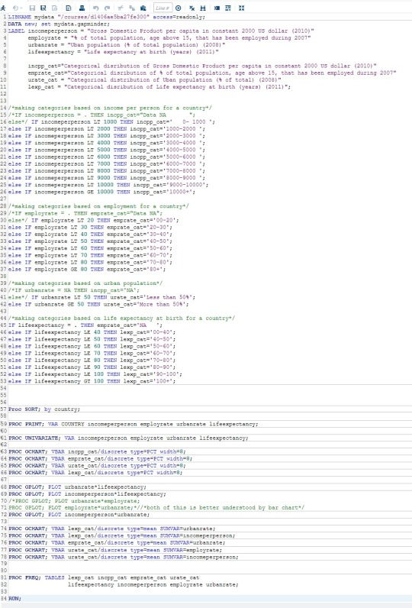

Note: As I copied the image from PDF its color scheme has changed and also for some variable I won’t be able to showcase their full freq. Procedure.

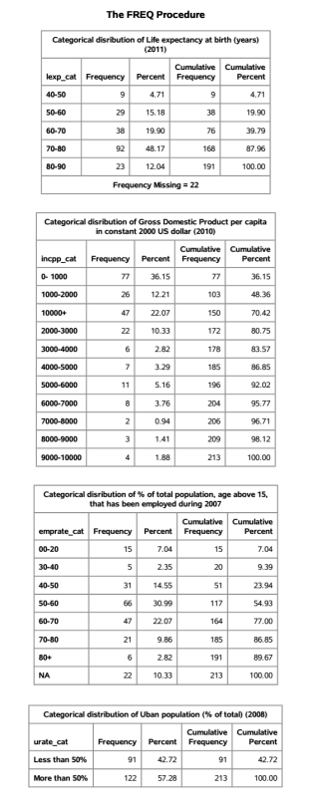

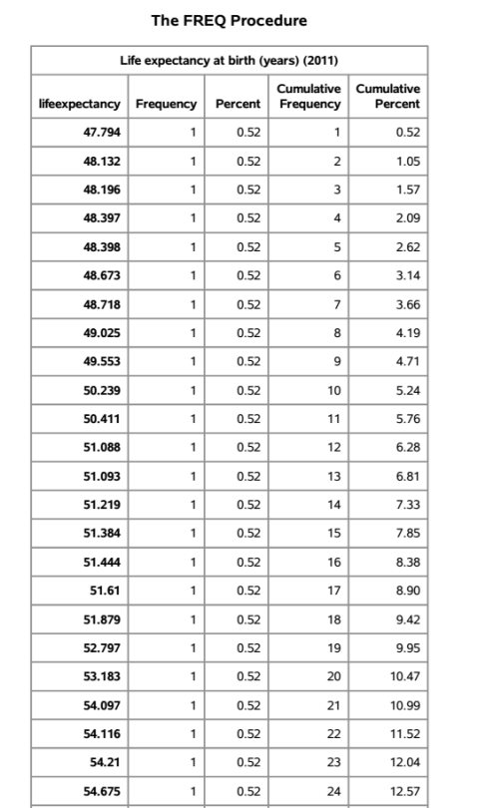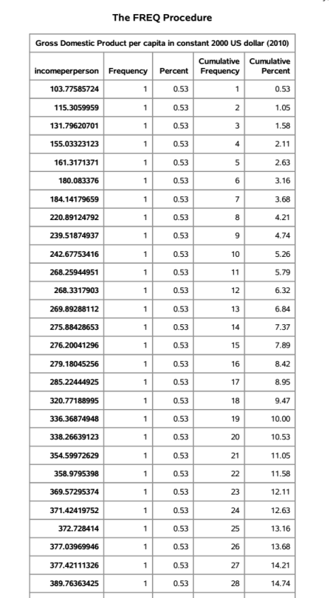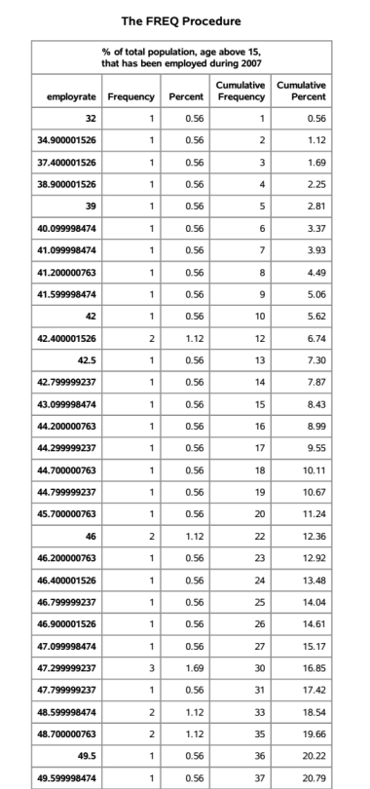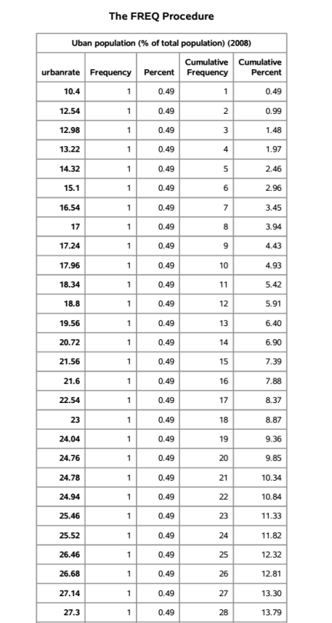

I collapsed the responses for incomeperperson, employrate, urbanrate, and lifeexpectancy to create four new categorical variables for each of them: incpp_cat, emprate_cat, urate_cat, and lexp_cat. These variable categorize the dataset for the variable into categories.

For lexp_cat, the most commonly endorsed response was ‘70-80′ (48.17%), meaning that most countries have an life expectancy in the age group of 70 and 80 years. Also among the 213 countries we are missing the data for 22 of them for this variable.

For incpp_cat, the most commonly endorsed response was ‘0-1000′ (36.15%), meaning that most countries GDP per capital lies in constant 2000 $ lies in 0 - 1000 $ group. Also looking at the data it can be said that the plot will have a skewed right distribution.

For emprate_cat, the most common endorsed response was ‘50-60′ (30.99%), meaning that for many countries comes in the range of having in between 50 to 60 % of total population, age above 15, that has been employed

during 2007. By looking at the data it seem this variable is having an approximate Gaussian curve with about center symmetric around 50-60 range. Also from among the 213 countries, dataset is missing the values for 22 countries.

For urate_cat, the most commonly endorsed response was ‘More than 50%’ (57.28%), meaning that among the 213 countries, 122 countries are having majority of its population living in urban areas and the majority population for the rest 91 countries is living in rural areas.

The above discussed variable significantly help in understanding the result and making the result concise that otherwise wold have been difficult to be discussed with the freq procedure for incomeperperson, employrate, urbanrate, and lifeexpectancy.